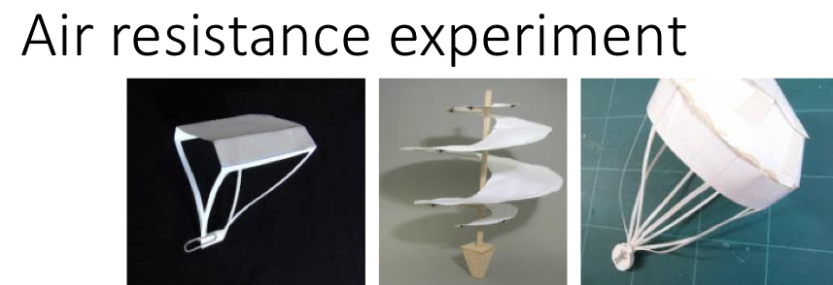
1.How long does it take a marble to fall to the ground from the height of the table?
2.Attach the marble to an 8.5X11" sheet of paper. How can you configure the paper to slow the marble the most? How slow can you get the marble to drop?
3.Use a newspaper, how slow can you get the marble to drop?
Draw your best improved designs using the small and large paper.

What are the advantages of the larger paper? What are the disadvantages?
1.How long does it take a marble to fall to the ground from the height of the table?
2.Attach the marble to an 8.5X11" sheet of paper. How can you configure the paper to slow the marble the most? How slow can you get the marble to drop?
3.Use a newspaper, how slow can you get the marble to drop?
Draw your best improved designs using the small and large paper.

What are the advantages of the larger paper? What are the disadvantages?
Spinners by _______________________________________________
Small spinner.  Record results for 5 tests. |  | LARGE spinner.  Record results for 5 tests. |  | Original spinner or your own design. Record results for 5 tests.
How many times did it spin before landing? | How long did it stay in the air? | How many times did it spin before landing? | How long did it stay in the air? | How many times did it spin before landing? | How long did it stay in the air?
What improvements did you make? |  | What improvements did you make? |  | What improvements did you make?

Draw below and describe the original variation you created on a spinner. What did you change: size, material, number of propellers, other.

Spinners by _______________________________________________
Small spinner.  Record results for 5 tests. |  | LARGE spinner.  Record results for 5 tests. |  | Original spinner or your own design. Record results for 5 tests.
How many times did it spin before landing? | How long did it stay in the air? | How many times did it spin before landing? | How long did it stay in the air? | How many times did it spin before landing? | How long did it stay in the air?
What improvements did you make? |  | What improvements did you make? |  | What improvements did you make?

Draw below and describe the original variation you created on a spinner. What did you change: size, material, number of propellers, other.

