Label the plane & describe what each part does by __________________________
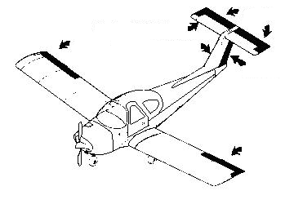
- aileron:
- cockpit:
- elevator:
- flap:
- fuselage:
- horizontal stabilizer:
- rudder:
- wing:

Label the plane & describe what each part does by __________________________
- aileron:
- cockpit:
- elevator:
- flap:
- fuselage:
- horizontal stabilizer:
- rudder:
- wing:

Describe what happens in each of these situations:
- Stall
- Dive
Describe modifications to solve each of these problems
- If the plane always goes to the right
- If the plane always goes left
- If the plane dives
- If the plane stalls

Describe what happens in each of these situations:
- Stall
- Dive
Describe modifications to solve each of these problems
- If the plane always goes to the right
- If the plane always goes left
- If the plane dives
- If the plane stalls

