Redraw the complete floor plans to half the size.
Count the blocks and divide in half. Points A and B should be as shown below
Label what you think each room could be (kitchen/bathroom, etc.
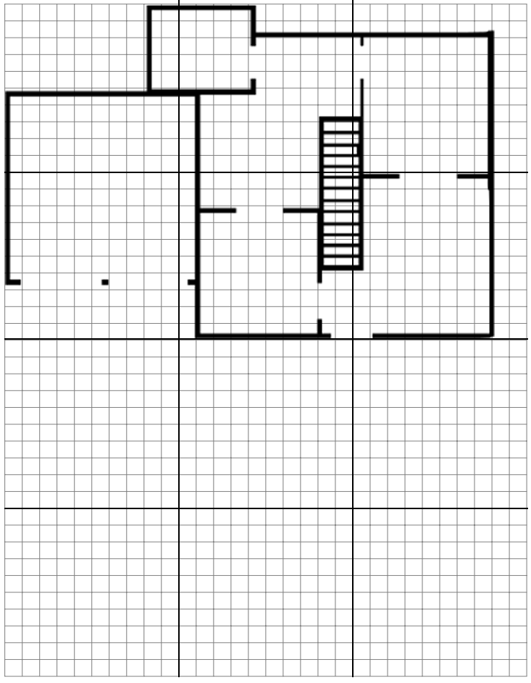

Redraw the floor plans to double the size. Start at point A
Label what you think each room should be (kitchen/bathroom, etc.)
