Activity 1.2.2 Analog and Digital Signals

Introduction
Even though this is a course in digital electronics, it is important to understand that the world around us is analog. Virtually everything that can be designed with digital electronics is used to either control or monitor something in the world around us, and this world is analog. Thus, to be an effective designer of digital electronics, it is important for you to understand the characteristics of both analog and digital signals.
In this activity you will examine several analog and digital signals to determine their amplitude, period, and frequency. Additionally, you will gain experience using the oscilloscope within the Circuit Design Software (CDS).
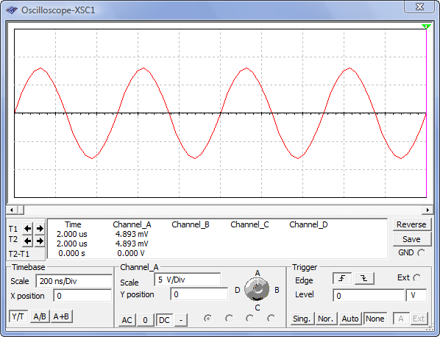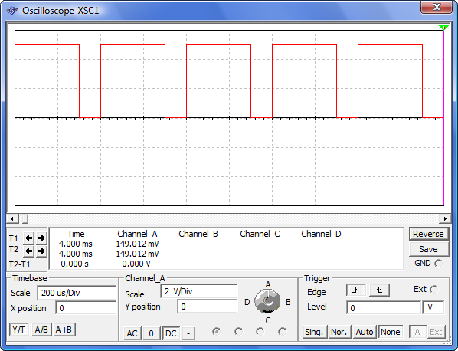
Equipment
- Circuit Design Software (CDS)
- Calculator

Procedure
- For each of the two analog signals shown below, determine their amplitude (peak), amplitude (peak-peak), period (T), and frequency (f). Be sure to put your answer in proper engineering notation and use the correct units.

Amp(peak):

Amp (peak-peak):

Period:

Frequency:

Amp(peak):

Amp (peak-peak):

Period:

Frequency:

Note: Why isn’t the above signal considered a digital signal?

- For each of the two digital signals shown below, determine the amplitude, period (T), frequency (f), time high (t_{H}), time low (t_{L}), and duty cycle (DC). Be sure to put your answer in proper engineering notation and use the correct units.

Amplitude:

Period:

Frequency:

Time High:

Time Low:

Duty Cycle:

Amplitude:

Period:

Frequency:

Time High:

Time Low:

Duty Cycle:

- Using the Circuit Design Software (CDS), enter the test circuit shown below. This circuit consists of a CLOCK_VOLTAGE, a DC_POWER (battery) and two 5v LAMPS. This circuit doesn’t really do much of anything useful other than make the two lamps flash, but we will be using it to gain experience using the oscilloscope to measure signals.
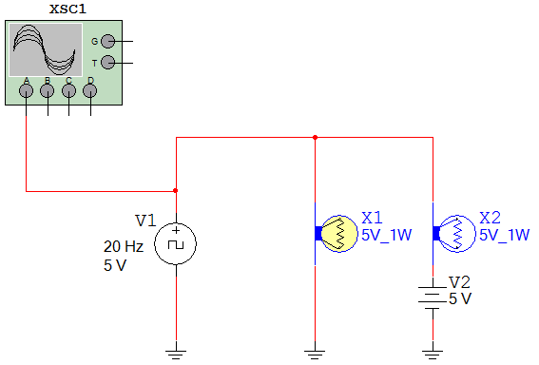

- Open the CLOCK_VOLTAGE component by double clicking on it and set the frequency, duty cycle, and voltage to 20 Hz, 10%, and 5 volts.

- Likewise, open the DC_POWER and set the voltage to 5 volts.

- Finally, connect the OSCILLOSCOPE to the positive side of the CLOCK_VOLTAGE component.

- Start the simulation. Are the lamps flashing? Does the flashing rate make sense for the frequency and duty cycle of the CLOCK_VOLTAGE? If not, review your setup and make any necessary corrections.

- Now that the circuit is working, use the oscilloscope to measure the signal being generated by the CLOCK_VOLTAGE. Use the markers to measure the period, time high, and time low. Use this data to calculate the frequency and duty cycle of the signal.

- Do the measured (and calculated) values match those set up in the CLOCK_VOLTAGE device? If not, review your measurements and make any necessary corrections.

Conclusion
- List the characteristic that makes a digital signal different from an analog signal.

- In the diagram shown below, label the parts of the analog signal.

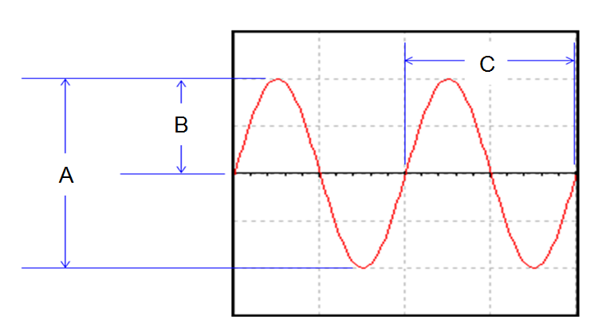
- In the diagram shown below, label the parts of the digital signal.
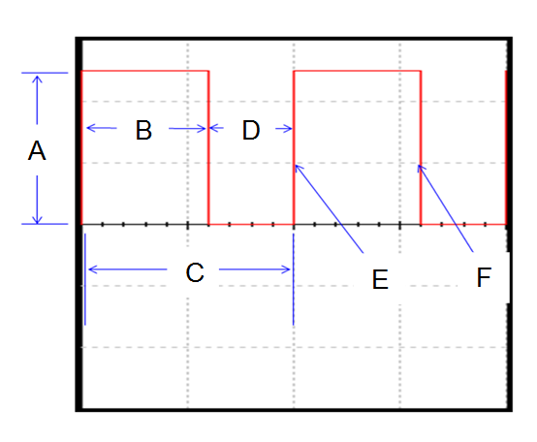
- What are the two standard voltage levels that are acceptable for a digital signal?

