Ohm’s Law
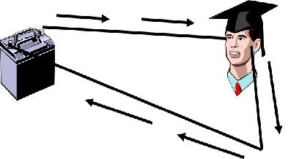
Lets say that the “head “ has a resistance of 10 Ohms of resistance…AND the Battery has a Voltage of 100 Volts. (Remember that about 0.5 Amps of electricity traveling through a person’s head is enough to kill them)
So… does ( insert name here) Live or Die?

Draw a series circuit

Draw a parallel circuit

Draw a mixed series/parallel circuit.

